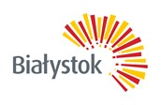
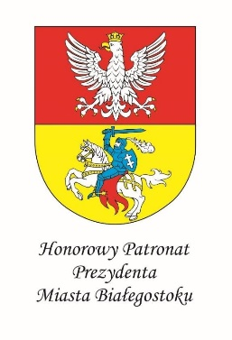

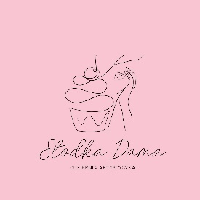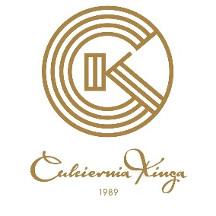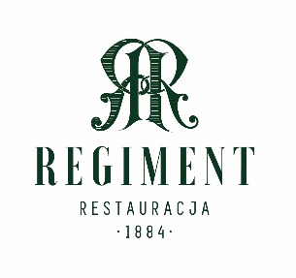
PATRONS

Gastronomic Contest Regulations
II edition
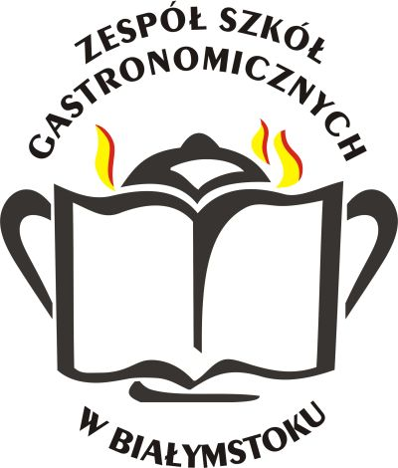

Białystok 2024r.
Gastronomic Contest Regulations
II edition

General Information

- The Gastronomic Contest (hereinafter reffered to as Contest) is organised by the Secondary Cookery School in Białystok (hereinafter reffered to as Organiser),
12 Knyszynska St., with the assisstance of institutions, companies and graduates cooperating with the school.
- Participants must be students from schools specialising in cookery, confectionery, hotel and tourism.
- Gastronomic Contest is organised in three categories: Waiting, Confectionery and Cooking.
- The Contest is organised in two phases: preliminaries are done online and the finals take place in the buildings of the Organiser.
- Schedule:

  - Application forms with statements are accepted until 10.02.2024 online (type of contest must be stated in the title) or by post:

Zespół Szkół Gastronomicznych
ul. Knyszyńska 12
15-702 Białystok
Email: a.samborska@zsg.bialystok.pl
  - Sent forms will be processed until 13.02.2024r.
  - The list of qualified students will be published until 14.02.2024 on the Organiser’s website www.zsg.bialystok.pl ; additionally, contestants will receive emails regarding qualifications.
  - Finals will take place on 11.03.2024 in the Secondary Cookery School in Bialystok.

- Sending the Form and Statement is understood as entering the Contest and agreement to terms.
Mrs Anna Samborska (a.samborska@zsg.bialystok.pl) , Head of the Vocational Subjects’ Teachers, is the contact person regarding the Contest.

The Organiser reserves the right to publish:
- Photos of meals and participants taken during the Contest
- Personal data of participants and their supervisors
- Names, recipes and photos of contestants’ dishes regardless of the Contest’s result

